**Global Sales Data Analytics**

**A PROJECT REPORT**

Submitted by

Hemadharshini K

Abinayashri KBS

Aarthi BG

Haritha M

**TEAM ID : PNT2022TMID04948**

**Project Report Format**

1. **INTRODUCTION**
   1. Project Overview
   2. Purpose
2. **LITERATURE SURVEY**
   1. Existing problem
   2. References
   3. Problem Statement Definition
3. **IDEATION & PROPOSED SOLUTION**
   1. Empathy Map Canvas
   2. Ideation & Brainstorming
   3. Proposed Solution
   4. Problem Solution fit
4. **REQUIREMENT ANALYSIS**
   1. Functional requirement
   2. Non-Functional requirements
5. **PROJECT DESIGN**
   1. Data Flow Diagrams
   2. Solution & Technical Architecture
   3. User Stories
6. **PROJECT PLANNING & SCHEDULING**

6.1 Sprint Planning & Estimation

6.2 Sprint Delivery Schedule

1. **TESTING**

7.1 Test Cases

7.2 User Acceptance Testing

**RESULTS**

Performance Metrics

1. **ADVANTAGES & DISADVANTAGES**
2. **CONCLUSION**
3. **FUTURE SCOPE**
4. **APPENDIX**

Source Code

GitHub & Project Demo Link

1. **INTRODUCTION**
   1. **Project Overview**

Sales Analysis is the process of understanding how your business performs in terms of sales. It provides insights into the past, present, and future performance of a business and can be used to help you forecast trends, identify opportunities for growth, and develop a strategic action plan for your company.

* 1. **Purpose**

The goal of sales analytics is always to simplify the information available to the sales and Marketing teams. It should help them clearly understand the team’s performance, sales trends, and opportunities to gain many insights and develop strategies that are better than the previous one.

1. **LITERATURE SURVEY**
   1. **Existing problem**

* The global sales and retail will primarily provide a platform to purchase, sell, distribution of items, product or service through the internet.
* This system is not much user-friendly as one needs to go to the market physically and then select items only from the available list.
* For this type of shopping, one needs to have an sample amount of free time.
* This system will provide the detailed description of the products to users so that they can compare to the different product and will by the one which is more suitable to them.
  1. **References**
* [1] Chaiyasoonthorn, W., & Suksa-ngiam, W. (2019). The Diffusion and Adoption of Electronic Payment Systems in Bangkok. International Journal of E-Business Research (IJEBR), 15(2), pp.102-115.
* [2] Nanda, N. N. (2019). The Influence of E-Commerce, Product Prices and Product Design on Purchasing Decisions in Souvenir Shop Tauko Medan. Budapest International Research and Critics Institute (BIRCI-Journal): Humanities and Social Sciences, 2(3), 388-395
  1. **Problem Statement Definition**
     + Collection dataset.
     + Upload the dataset into cognos.
     + Open the properties->data module.
     + If null value is present in character ﬁeld use mode method.
     + If the null value is present in continuous ﬁeld use average or medium.
     + Display the data in respective charts.
     + Create conclusion using summary.

1. **IDEATION & PROPOSED SOLUTION**
   1. **Empathy Map Canvas**

* An empathy map is a tool which aids in understanding another person's perspective.
* Empathy maps have up until now not been used in a medical education setting.
* Objective: To assess the attitudes towards, applicability and usefulness of empathy maps as part of medical student's communication skills training.

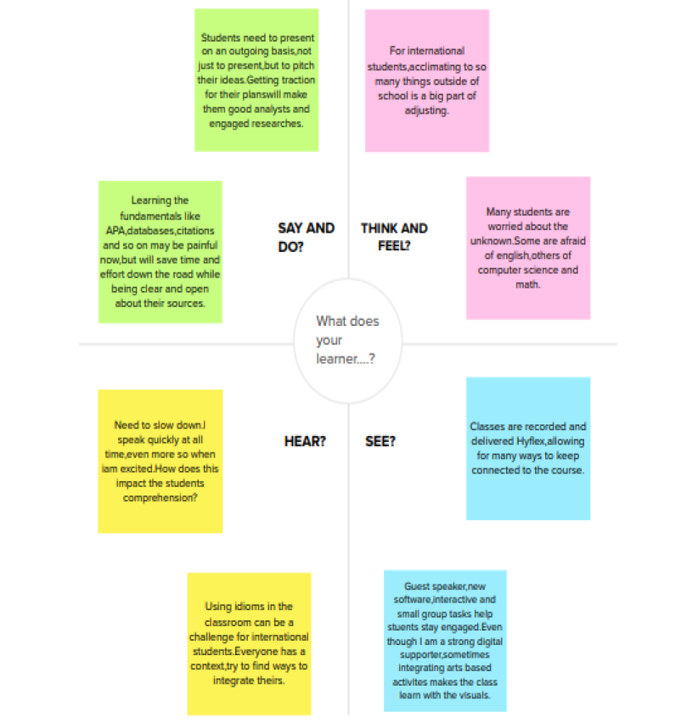

* 1. **Ideation & Brainstorming**
* To try to solve a problem or come up with new ideas by having a discussion that includes all members of a group : to discuss a problem or issue and suggest solutions and ideas.



* 1. **Proposed Solution**

|  |  |  |
| --- | --- | --- |
| **S.No.** | **Parameter** | **Description** |
| 1. | Problem Statement (Problem to be solved) | * Decision makers of E-commerce   companies(User) need a way to comprehend raw data, analyse and make more informed business decisions.   * E- commerce companies(User) need a way to understand the shift in preferences of   customers and the current trend, so that they can satisfy the customers. |
| 2. | Idea / Solution description | A powerful and easy-to-use sales analytics tool that automates and visualizes sales trends to optimize business outcomes. |
| 3. | Novelty / Uniqueness | * Interactive Dashboard and simple UI * Dynamic and real time analytics * AI based predictions and forecasting |
| 4. | Social Impact / Customer Satisfaction | * Visible profits driven by informed decisions * Optimize sales and marketing * Ability to react to competitor’s strategies |
| 5. | Business Model (Revenue Model) | Three tier pricing- Basic, Standard, Enterprise   * Basic: Limited features targeting startups and individuals. * Standard: Limited premium features. Target customers- Medium Scale businesses. * Enterprise with all premium features targeted at Large corporations. |
|  | Scalability of the Solution | * More B2B customer services can be provided alongside * Usable by all customer facing companies and startups of all scale |

* 1. **Problem Solution fit**

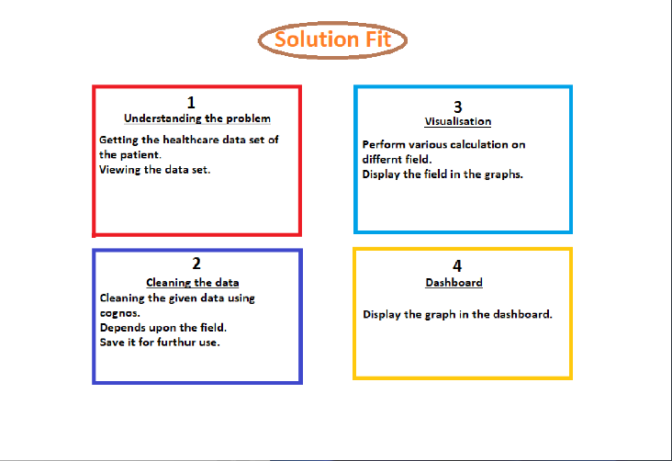

1. **REQUIREMENT ANALYSIS**
   1. **Functional requirement**

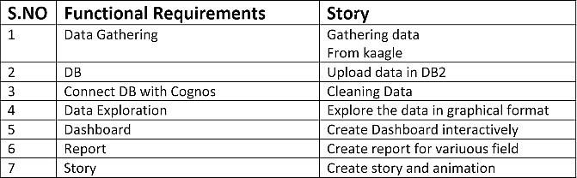

* 1. **Non-Functional requirements**



1. **PROJECT DESIGN**
   1. **Data Flow Diagrams**

A data ﬂow diagram shows the way information ﬂows through a process or system. It includes data inputs and outputs, data stores, and the various sub processes the data moves through. DFDs are built using standardized symbols and notation to describe various entities and their relationships.

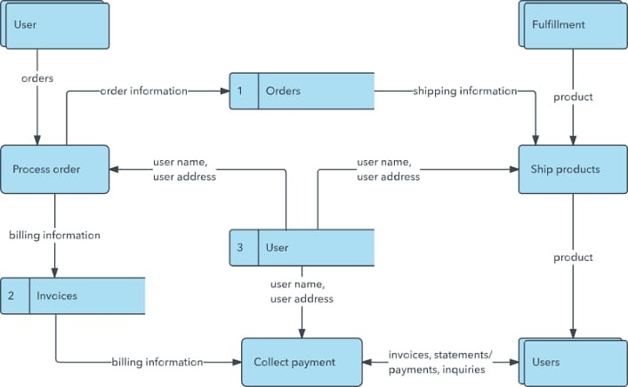

* 1. **Solution & Technical Architecture**
* Solution Architects are most similar to project managers, ensuring that all parties, including stakeholders, are on the same page and moving in the right direction at all stages.
* Technical architects manage all activities leading to the successful implementation of a new application.

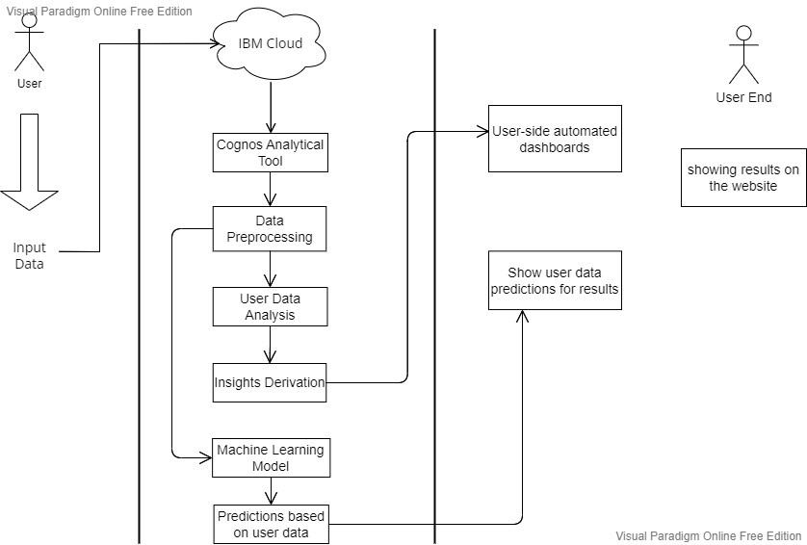

* **Components & Technologies:**

|  |  |  |  |
| --- | --- | --- | --- |
| **S.No.** | **Component** | **Description** | **Technology** |
| 1 | User Interface | User uploads the csv or excel format files into the web pages | HTML, CSS, JavaScript |
| 2 | Application Logic-1 | The user data will pass into the IBM cloud for storing and acts as a data source | IBM cloud |
| 3 | Application Logic-2 | In cloud, data will be fetched by the Cognos analytical tool for data analysis | IBM Cognos analytical tool |
| 4 | Application Logic-3 | The pre-trained Dashboards will be present to perform analysis on the incoming data | IBM Cognos analytical tool |
| 5 | Database | Data will be retrieved from cloud | MySQL |
| 6 | Cloud Database | Database Service on cloud | IBM DB2, IBM Cloud |
| 7 | File Storage | Customer sales data is uploaded in cloud through interface | IBM Block Storage or Other Storage Service or Local Filesystem |
| 8 | External API-1 | To perform data analysis on the user data | IBM Cognos Tool |
| 9 | External API-2 | To build the machine learning model for classification | Jupiter Notebook |
| 10 | Machine Learning Model | To do the predictive analysis on the input data | Predictive analysis model, etc. |
| 11 | Infrastructure (Server / Cloud) | Application Deployment on Local System / Cloud  Local Server Configuration: Using the flask Cloud Server Configuration: IBM cloud | Local, Cloud Foundry |

* **Application Characteristics:**

|  |  |  |  |
| --- | --- | --- | --- |
| **S.No** | **Characteristics** | **Description** | **Technology** |
| 1. | Open-Source Frameworks | Google Collaboratory, Jupyter notebook | Google |
| 2. | Security Implementations | To protect data from the unauthorized access | 256-bit AES algorithm |
| 3. | Scalable Architecture | Supports various data sizes | IBM Cloud |

* 1. **User Stories**

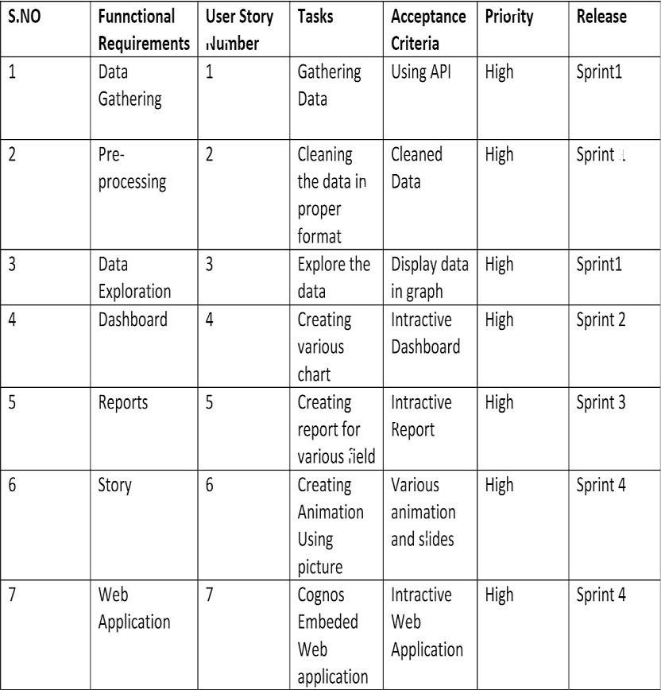

1. **PROJECT PLANNING & SCHEDULING**

**6.1Sprint Delivery Schedule**

### 

### 6.2 Sprint Planning & Estimation

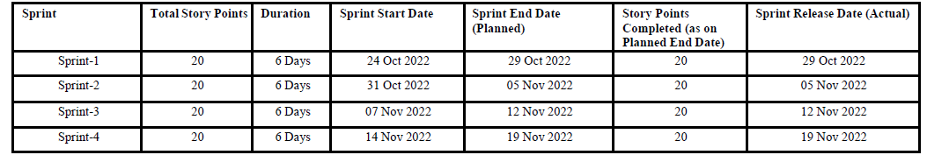

**7. Testing**

### 7.1 Test Cases

* Verify user is able to see Home page.
* Verify user is able to see Dashboard page.
* Verify user is able to navigate to Report page.
* Verify user is able to navigate to story page.
* Verify ﬁlters are working

**7.2 User Acceptance Testing**

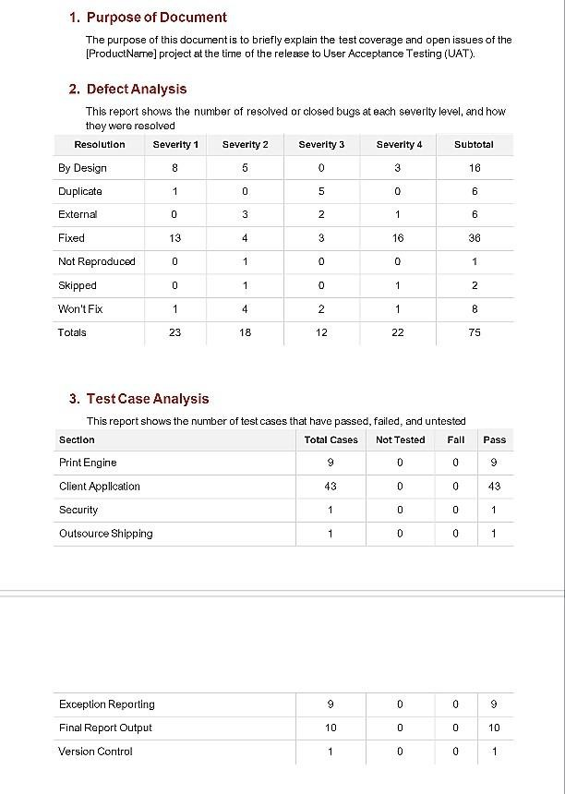**8.** **Results**

**8.1 Performance Metrics**

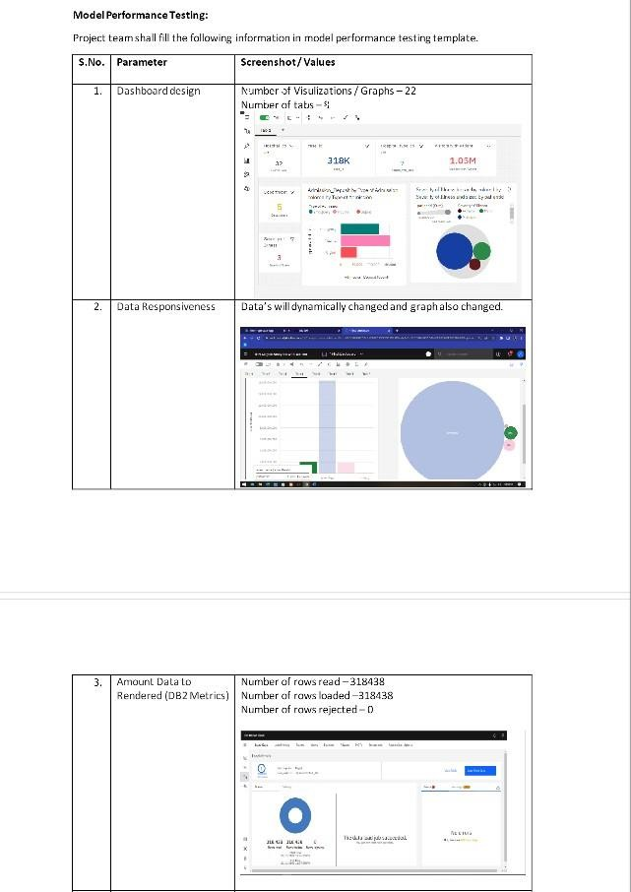

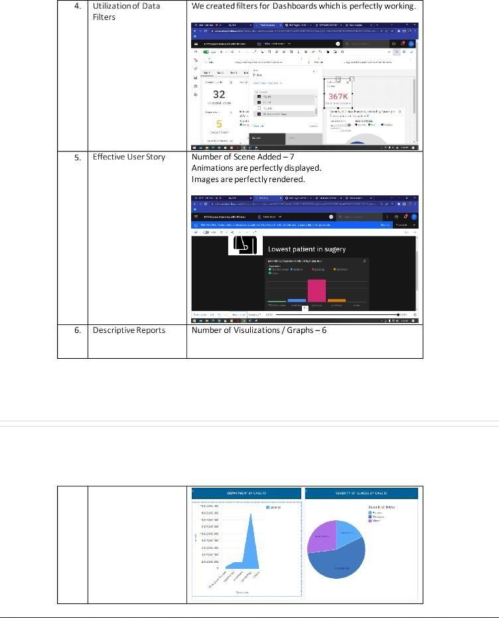

**9. ADVANTAGES**

* User friendly user-interface to access the website.
* Enable Deals, Bargains, Coupons, and Group Buying
* Affordable advertising and marketing.
* Flexibility for customers & No reach limitations.
* Virtual Assistant plays major role of Data Owner for time consumption process.
* Several payment modes.

# **DISADVANTAGES**

* Privacy
* Replacing Doctors
* Frustration with poor implementation. Cybersecurity risks
* Healthcare Regulatory Changes.
* Healthcare Staffing Shortages

**10. FUTURE SCOPE**

• Online websites now provide detailed descriptions of their products so that the customers have a clear idea. Many websites also provide feedbacks that other users have given. This helps in assuring other prospective customers.

• A huge plus point while doing business online is the lack of need for an infrastructure with which the customer could judge the business. Any online business can sell their products from their own rooms, garages, or even the back of their car.

1. **Conclusion**

• From the design, this design has fulfilled the basic requirement of a comfortable design and practibility based on various statement of the experts.

• Therefore, this design can be used because it ful fill the standard qualification for e-commerce website that is easy to use and visually comfortable.

**GITHUB LINK:**

<https://github.com/IBM-EPBL/IBM-Project-7922-1658902945>

**Demo Video:**

<https://drive.google.com/file/d/114taTlKEWuq2Oa572r3RWdGAyBLBtOOm/view?usp=sharing>